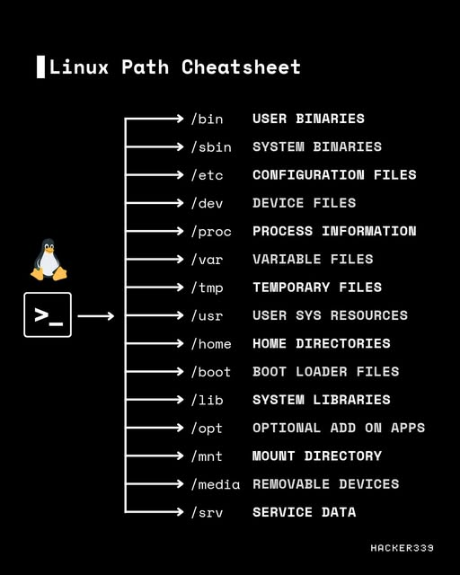

Linux Path Cheatsheet 🐧

Think of Linux like a big cupboard 📂. Each folder has its own job.

⬛/bin – User Programs

▪️Everyday commands you use (like ls, cp).

⬛/sbin – System Programs

▪️Important commands for admins (e.g. fixing system).

⬛/etc – Settings Folder

▪️All configuration files (like network, user settings).

⬛/dev – Device Connect

▪️Shows devices like USB, hard disk as files.

⬛/proc – Process Info

▪️Live info of running system & hardware.

⬛/var – Changing Data

▪️Logs, cache, emails—data that keeps changing.

⬛/tmp – Temporary Place

▪️Stores short-time files; auto-clears on reboot.

⬛/usr – User Software

▪️Apps, games, extra software live here.

⬛/home – Personal Space

▪️Each user’s own folder (like Documents, Pictures).

⬛/boot – Start-up Files

▪️Holds files to boot/start Linux.

⬛/lib – Support Files

▪️System libraries that programs need.

⬛/opt – Optional Apps

▪️Extra add-on software installed here.

⬛/mnt – Mount Spot

▪️Temporary mount for external drives.

⬛/media – USB/CD Drive

▪️Auto-mount removable devices.

⬛/srv – Service Data

▪️Stores data for web/ftp servers.

---